Second Hand Car Dealer

1. READ DATA

Code :-

SELECT\*FROM car;

Out Put :-

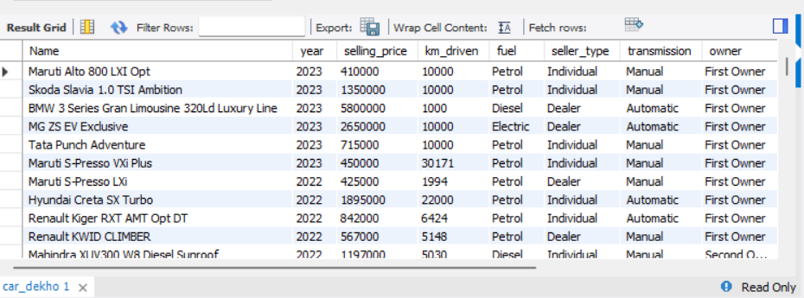

1. cars: To get a count or total records

Code :-

SELECT COUNT(\*) FROM car;

Out Put :-

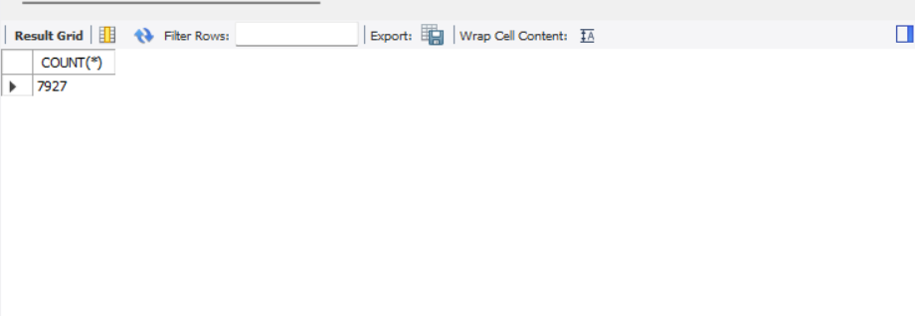

1. The manager asked the employee How many cars will be avilable in 2023?

Code :-

SELECT COUNT(\*) FROM car WHERE YEAR = 2023;

Out Put :-

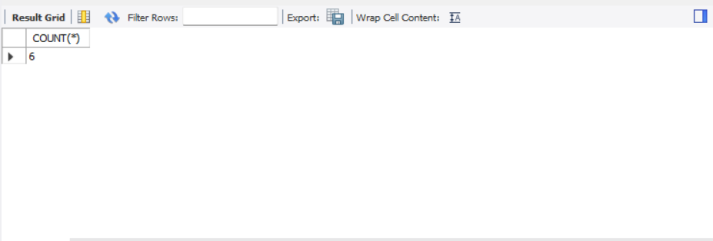

1. The manager asked the employee How many cars will be avilable in 2020 , 2021, 2022?

Code :-

SELECT COUNT(\*) FROM car WHERE YEAR IN

(2020,2021,2022) GROUP BY YEAR;

Out Put :-

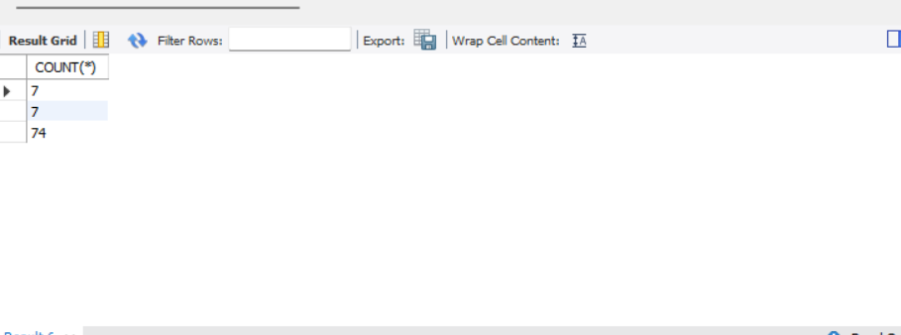

1. Clint asked me to print the total of all cars by year. I dont see all the details.

Code :-

SELECT YEAR, COUNT(\*) FROM car GROUP BY YEAR;

Out Put :-

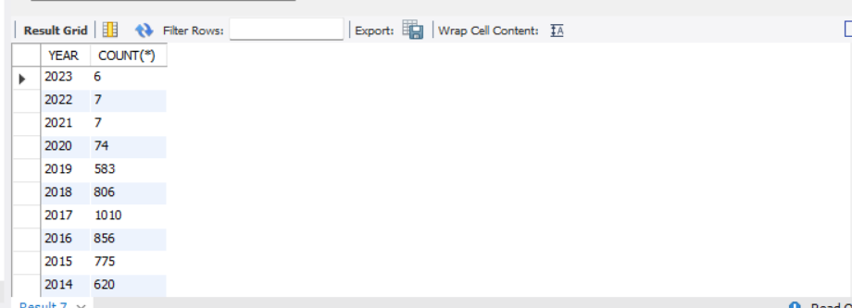

1. Clint asked to car dealer agent How many diesel cars will there be in 2020?

Code :-

COUNT(\*) FROM car WHERE YEAR = 2020 AND fuel =

"Diesel";

Out Put :-

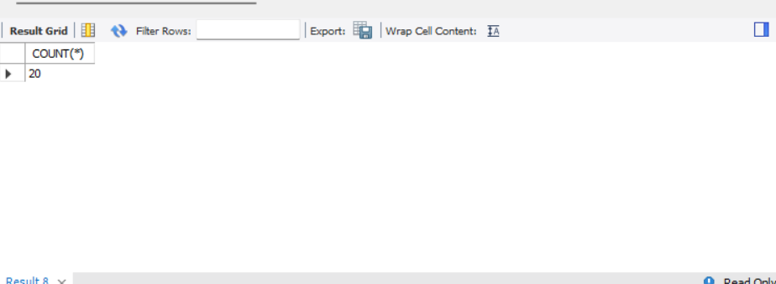

1. Clint requested a car dealer agent How many petrol cars will there be in 2020?

Code :-

SELECT COUNT(\*) FROM car WHERE YEAR = 2020 AND

fuel = "Diesel"

Out put :-

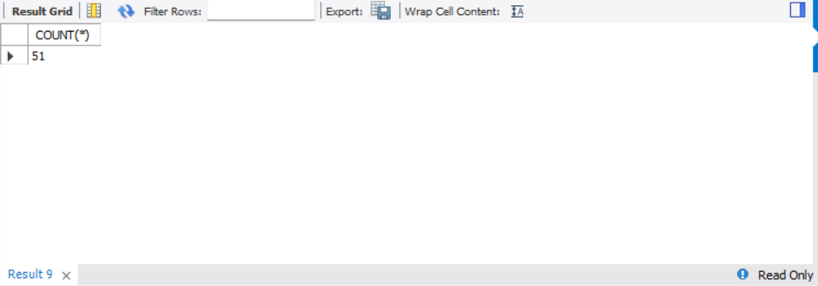

1. The manager told the employee to give a print all the fuel cars (petrol,diesel,and CNG)come by all year.

Code :-

SELECT YEAR, COUNT(\*)

FROM car

WHERE fuel IN ('Petrol', 'Diesel', 'CNG')

GROUP BY YEAR;

Out put :-

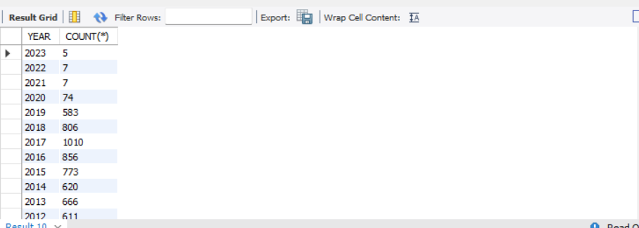

1. Manager said there were more than 100 cars in a given year, which year had more than 100 cars?

Code :-

SELECT YEAR , COUNT(\*) FROM car GROUP BY YEAR

HAVING COUNT(\*)>100;

Out put :-

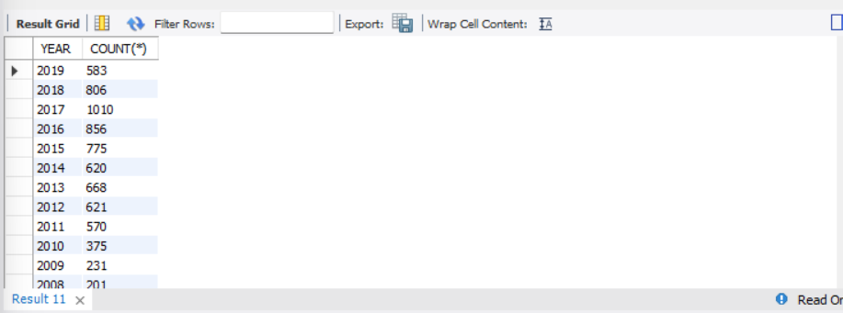

1. The manager said to the employee All cars count details between 2015 and 2023, we need a complete list.

Code :-

SELECT COUNT(\*) FROM car WHERE YEAR BETWEEN

2015 AND 2023;

Out put :-

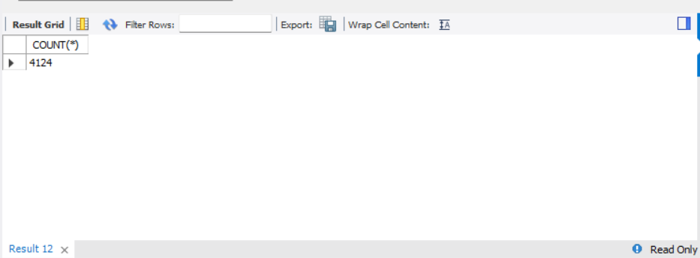

1. The manager said to the employee All cars details between 2015 to 2023 we need complete list.

Code :-

SELECT \* FROM car WHERE YEAR BETWEEN 2015 AND

2023;

Out put :-

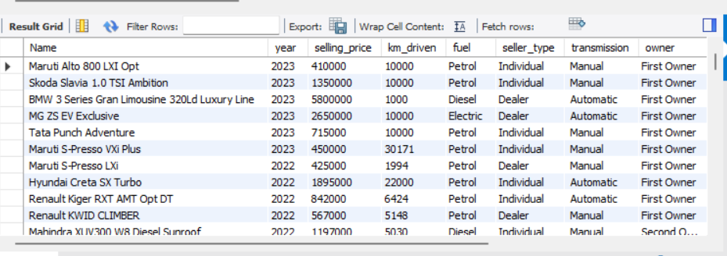

-- END --